**Proposal - Foodbulous**

1. **Indroduction**

**介绍产品+介绍公司+介绍组员**

1. **（宏观）Market Analysis 【孙冠琳】**
   1. rival：

There’s no doubt that Openrice is the industry key player of Hong Kong food review websites. After meeting with Keith, it is ensured that foodbulous does regard openrice as its main rival.

Openrice now has a huge market share. It has more than 3 million monthly users, 83 million page views, more than 450,000 registered members, and 500,000 reviews. OpenRice ranks 29th on the entire Hong Kong website, with about 66% of traffic coming from Hong Kong. OpenRice has more than 41,000 restaurants in Hong Kong, Macau and Shenzhen, of which Hong Kong accounts for 21,000.

However, many problems with openrice cannot be ignored. For restaurant finders, the restaurant recommended by Openrice is not delicious. Because too many comments are made by ‘打手’. The Openrice platform is also full of advertisements, affecting users' feeling.

For reviewers, when they write reviews in OpenRice, they need to wait for ‘moderate’, and they don't know how long to wait. What’s more, their bad reviews may be blocked. Some people enthusiastically publish food reviews because they want to be KOLs, however, the KOL group on Openrice has been finalized, and it is difficult for newcomers to become famous.

As Keith said, no one likes Openrice. This gives Foodbulous a chance to solve the problems brought by Openrice and meet the needs of users that Openrice can't meet.

1. **（具体）Product Analysis**
2. misson【夏聪聪】
3. swot analysis【薛徐婷】

Strengths:

For users:

* Emphasis on the interactions between friends: After registering a Foodbulous account with Facebook, users can see those restaurants and related food reviews recommended by their friends in Foodbulous's "Dynamic News" column. At the same time, after writing a food review in Foodbulous, users can also share it share it with more friends through Facebook.
* There are very few false comments in Foodbulous: OpenRice hires a lot of people to write fake information, and many of the search results and evaluations in OpenRice are untrustworthy. The evaluation of Foodbulous is freely released by users and has higher credibility.
* "Food Group(食組）" function is added to allow users to better manage and browse their favorite restaurants: "Food Groups" are different lists that consist of different type of restaurants through users’ regions, unique tastes, unique needs, different consumer orientations, Michelin recommendation and so on. These groups are established by "Foodies (食家)". It is not mandatory to submit comments in the " Food Group ", and the Foodies are free to establish unlimited " Food Group ".

For the store:

* Support small stores, no recommendation fees: For restaurants, in addition to registration on Openrice, other services generally need to pay, and the cost is very expensive. Different from Openrice, Foodbulous promotes the restaurant in a freeway. Although the app is also maintained by advertising, it insists that no advertising fees will be charged to restaurants.
* Manager s have the opportunity to tell the story behind the store: As mentioned by Keith, Foodbulous not only pays attention to the restaurants ' special dishes, but also intends to know the story behind the restaurants.

Weaknesses：

* The database is incomplete and the update is slow. The last update was in 2017, and the number of restaurants that can be searched on the app is limited.
* The propaganda channel is narrow. It is difficult to let more users know the app only through the propaganda of acquaintances. And Foodbulous's social media account is not operated well and has no attractive content.
* The software is not user-friendly and the content is too fragmented and complicated. The structure is confusing, and it is difficult for users to find the content they need.
* At present, the scale of users is too small to collect data. And there is no contact channel such as the user's mailbox to push information to users, so it is difficult to establish a user database.

Opportunities:

* The catering industry in Hong Kong is developing rapidly. Correspondingly, catering-related software also has great room for development.
* Consumers are diverse. A large number of users are tired of Openrice's false comments and are looking for new apps to find good restaurants.
* The successful experience of the Mainland can be applied to the Hong Kong market and can be internalized and adjusted according to the user habits of Hong Kong people.

Threats:

* The competition of the catering industry in Hong Kong is fierce, and there are a wide variety of catering apps. At present, the Openrice is dominant in the industry, which squeezes the development space of the new app.
* There are too many competitors like Foodbulous, such as Eatchoice and iPick, whose main design idea is to share the food information with friends.

1. usp【夏聪聪】
2. product features-現有架構【唐叶丹】
3. business model【唐叶丹】

**d. Product Features**

There are five pages on Foodbulous: News Feed, Discover, Restaurant, Foodie and Profile

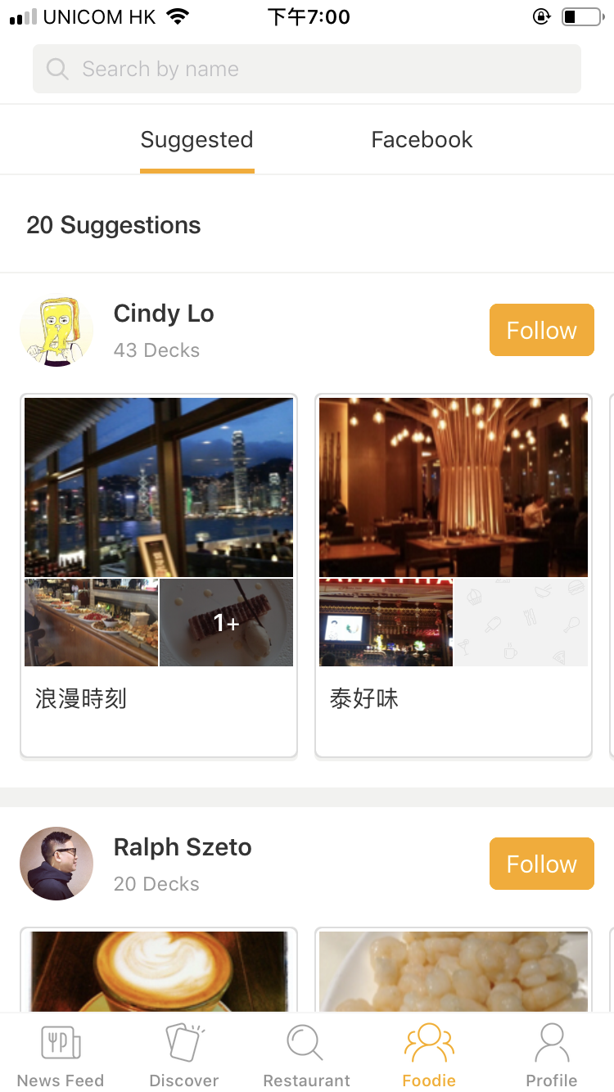

In order to better introduce their contents, we group these pages according to their functions:

1) Social Function Pages:

---Foodie,  News Feed and Profile

①Foodie Page: Showing a list of users one could follow on Foodbulous.

--- Includes suggested stranges and automated loaded-in facebook friends

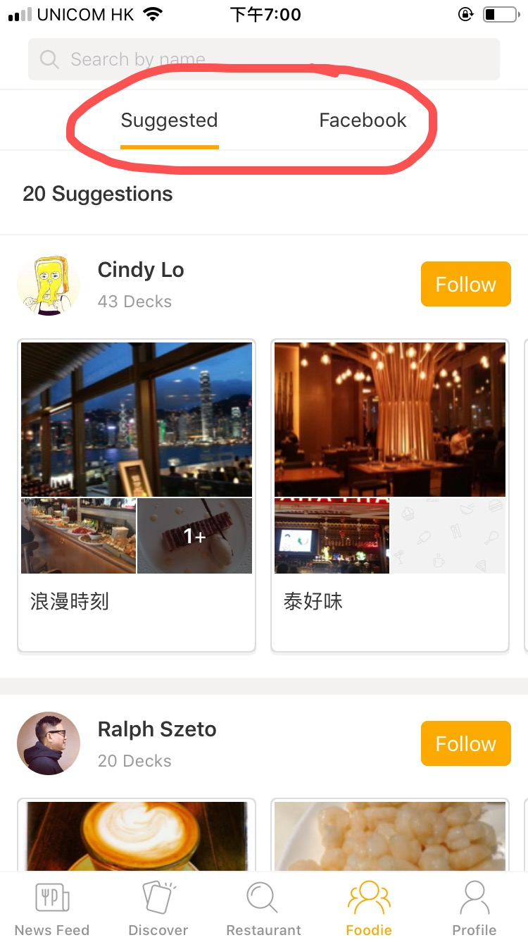 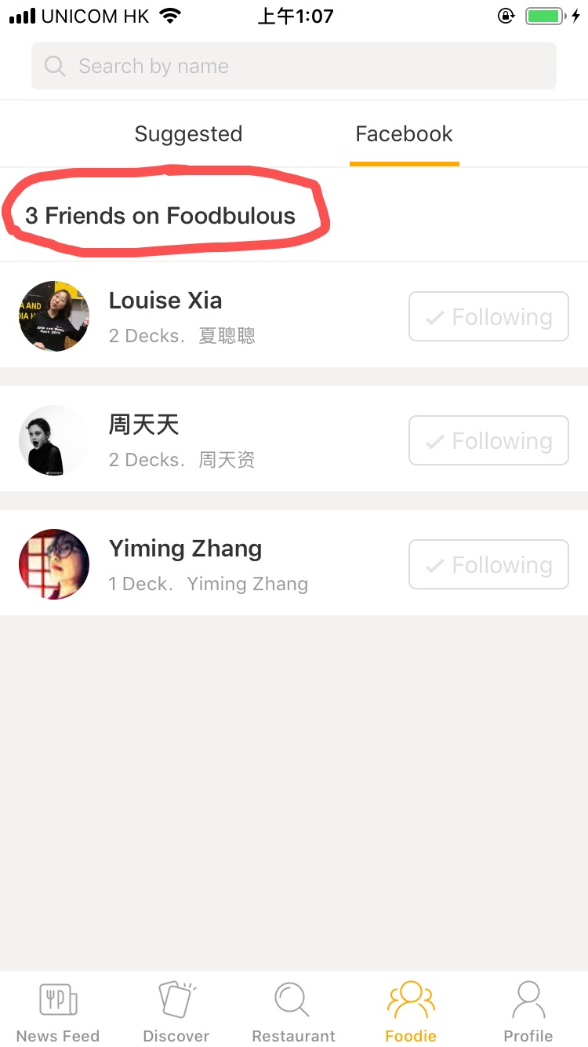

② News Feed Page: Food reviews posted by the users one follows

--- Views of uses’ friends will be shown on the top

--- In the latest app version, users can like or share others’ posts, but not making comments or reply

--- Each food review links to a single page of the restaurant

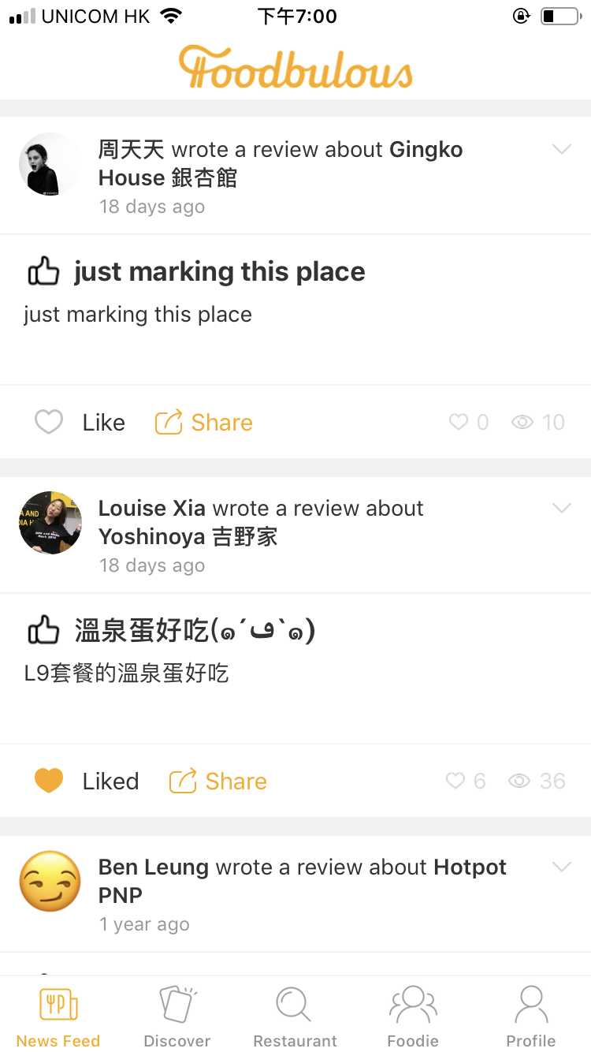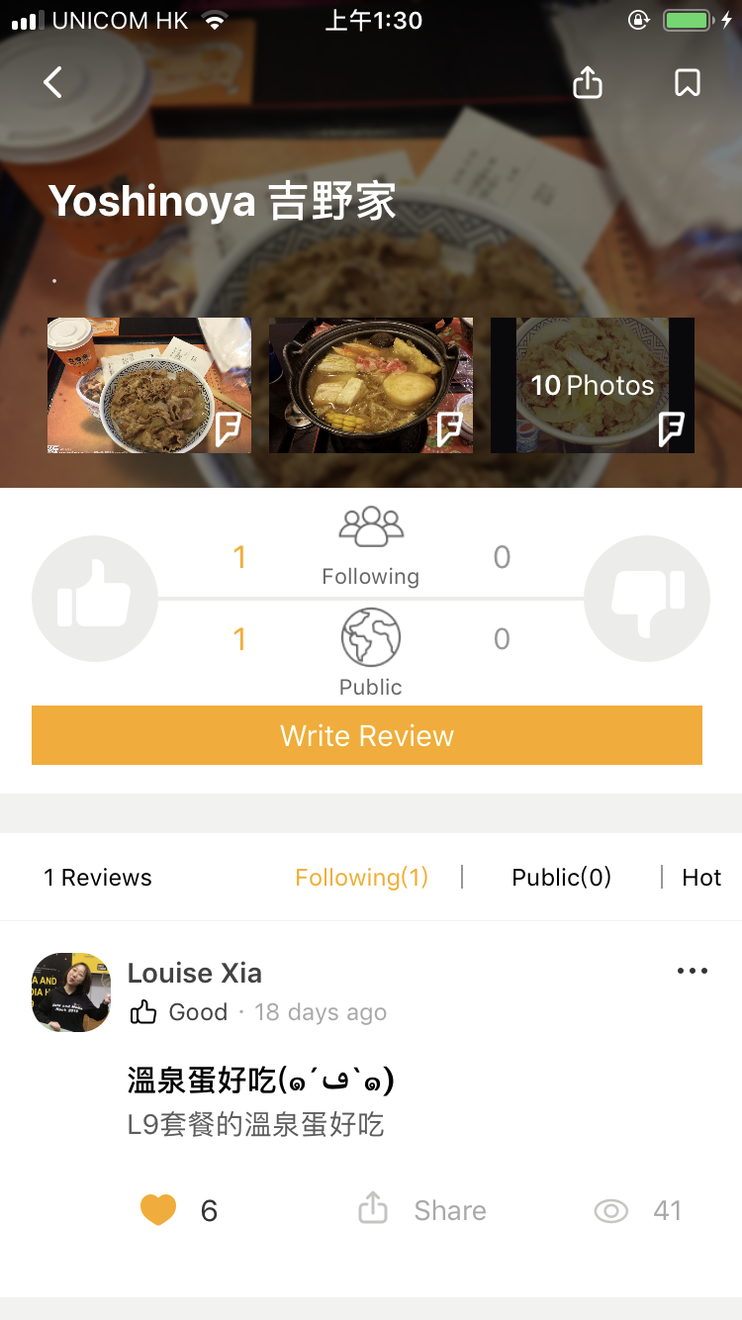

③ Profile Page: Users’ own profile page

--- Displaying users’ ”favorite desks” of restaurants (the restaurants that you marked)

--- User can build, name their desks(favorite restaurant lists) freely, and tag them with different theme, district and dish labels.

--- Showing one’s following and followers number

--- Food reviews are not directly shown on this page

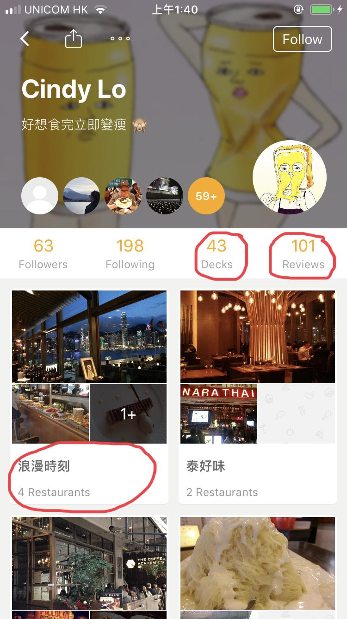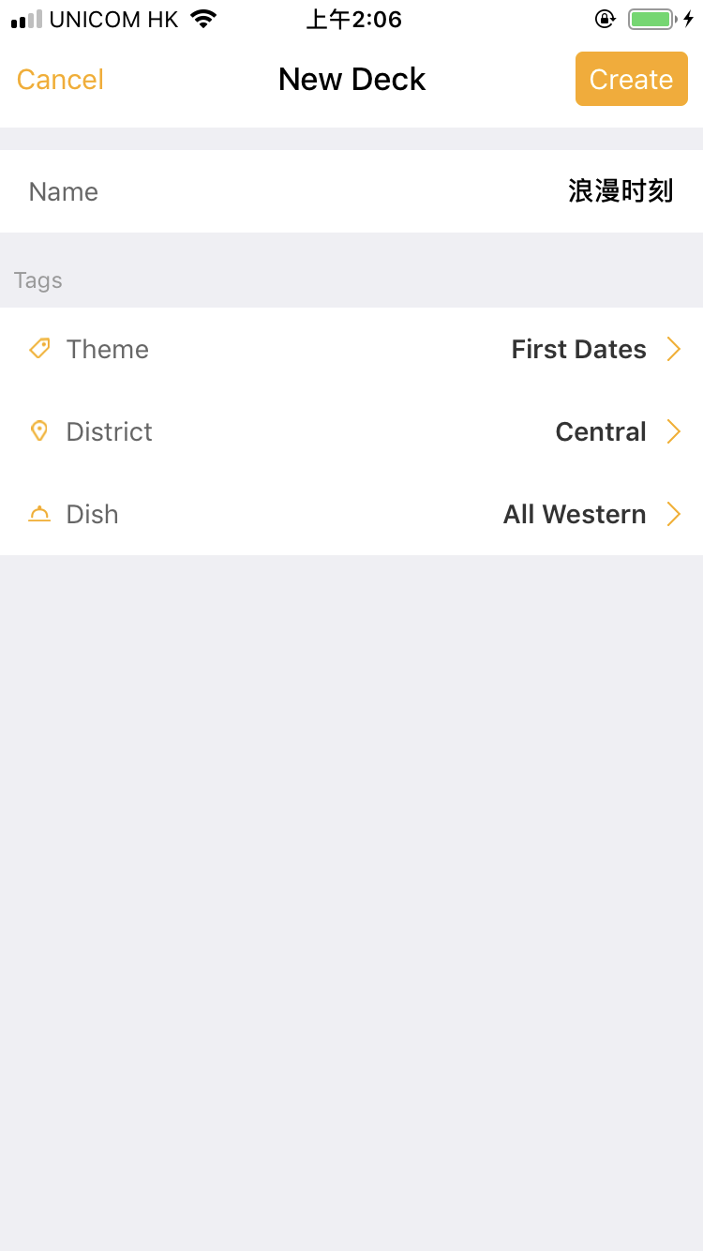

**Summary:**

**Major user journey:**

--- Follow Foodies --> Read their posts --> Learn about an intersting restaurant -->stamp the resaturant --> From a deck

--- Being asked to recommand some restaurants --> send a restaurant deck to the friend

**Connection:**

--- Food review is the core link between user network and restaurant database.

2) Search Restaurant Function Pages:

* Discover and Restaurant

①Discover Page: Theme-based Restaurant Searching System

--- Displaying a number of themes cards of different styles of restaurants

--- Users can apply three filters: theme, district and dish to find the proper restaurant they need

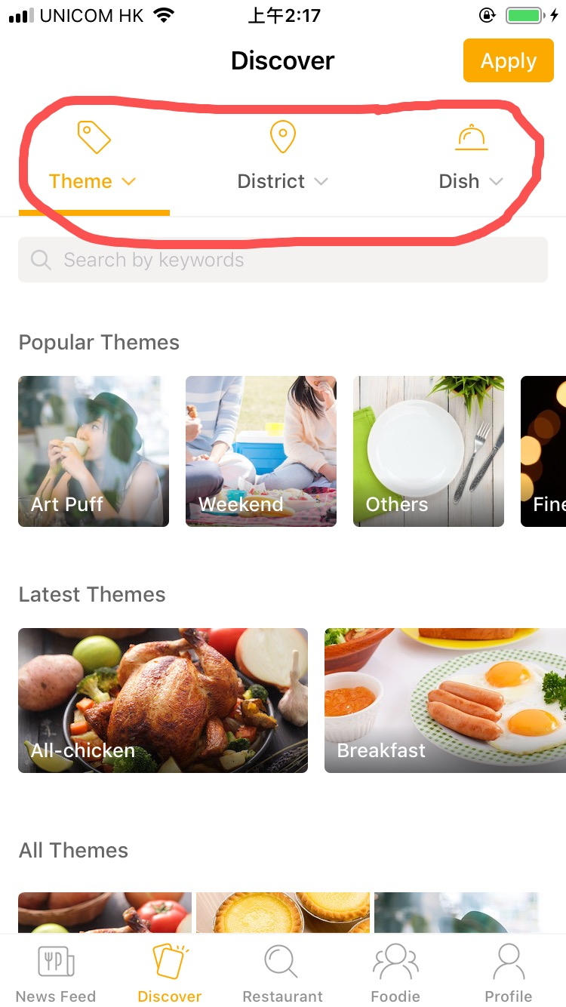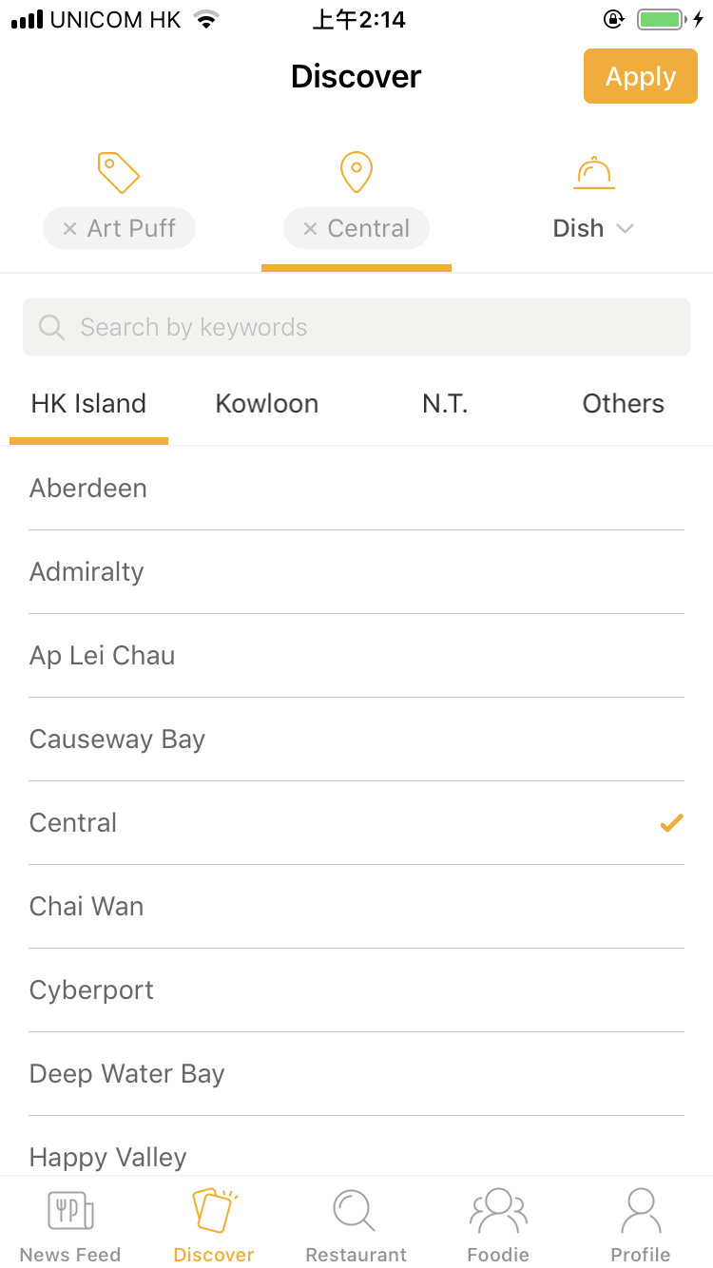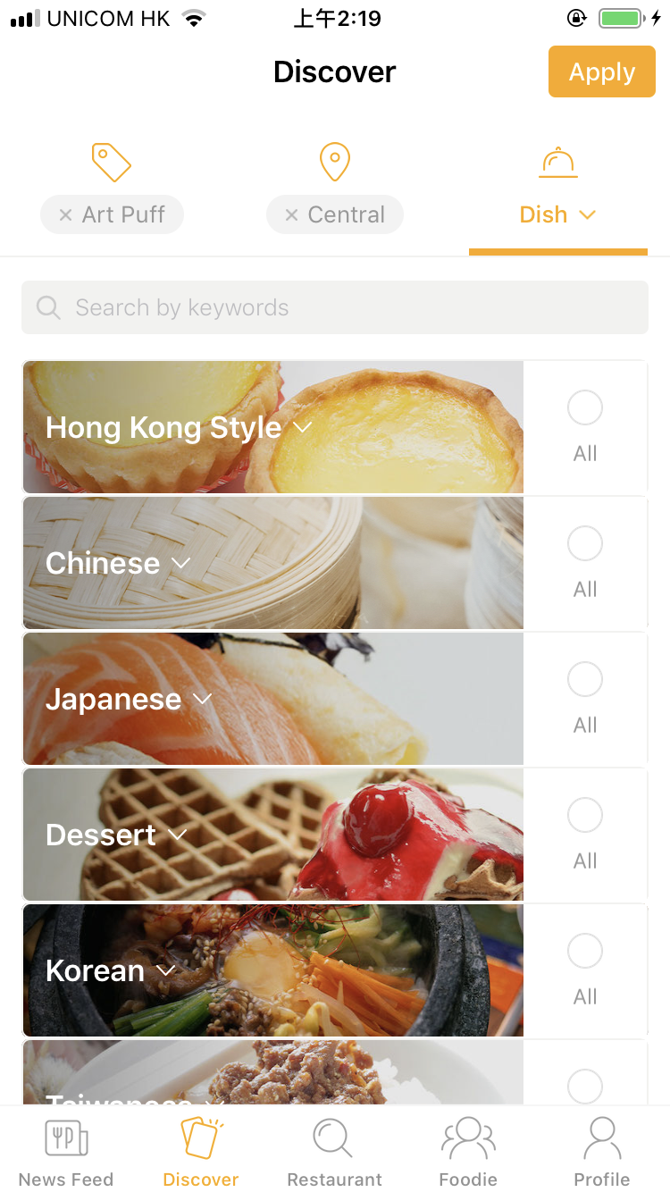

②Restaurant Page: Direct Search of restaurants

--- User can use the two top search bars to search restaurants by names or districts

--- Each result record have the restaurant name and address, but no price and foodtype

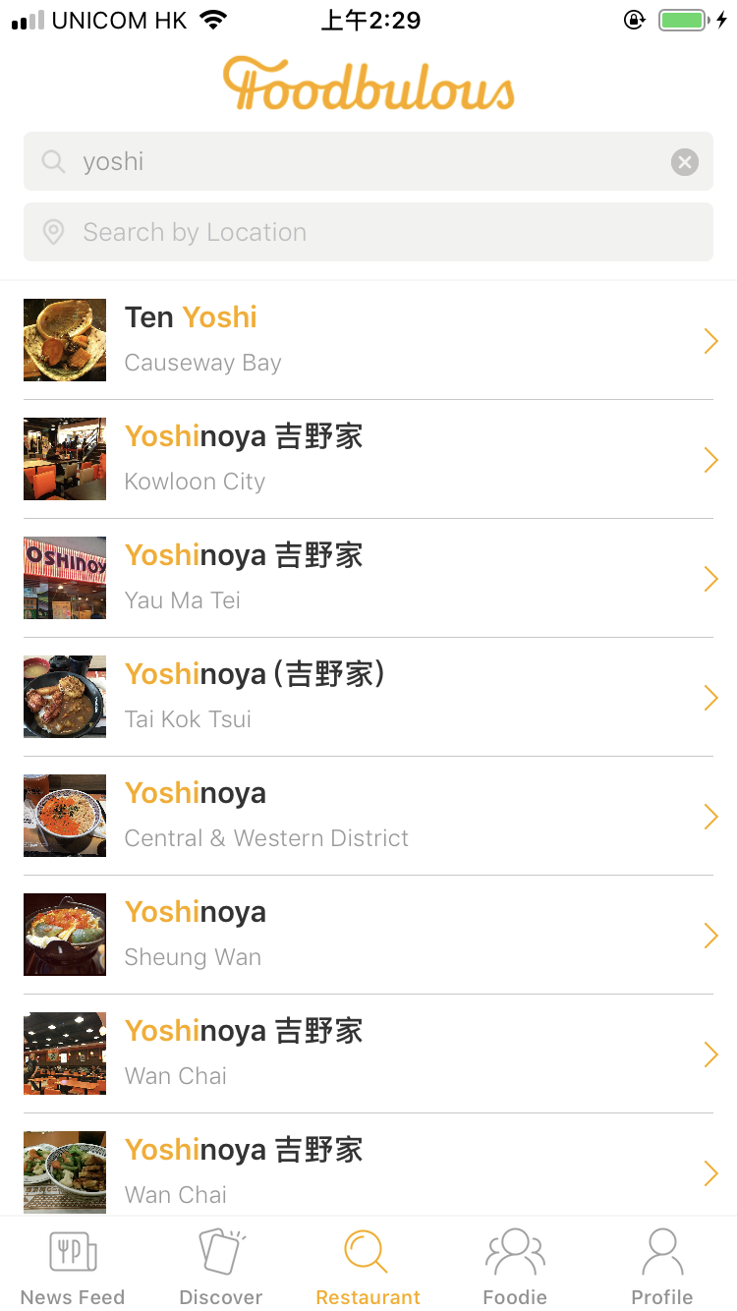 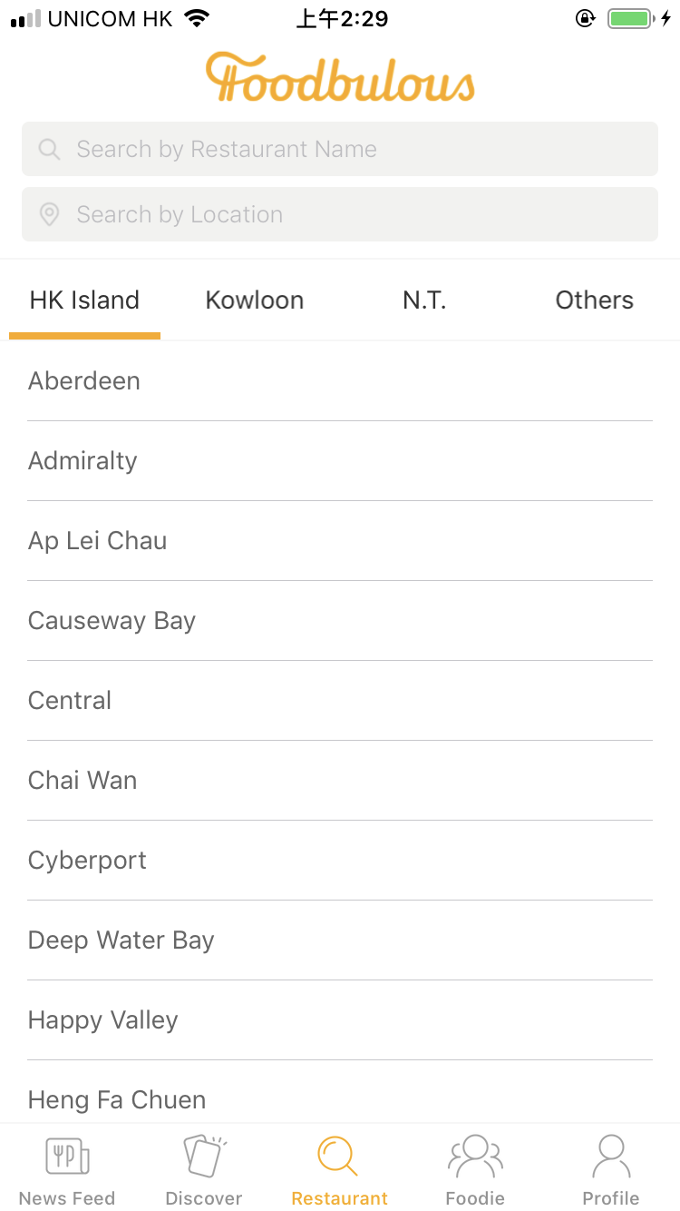

③ Restaurant single page:

--- Basic information of the restaurant

--- Rate and review are displayed in two sperate channels: Friends and Pubic(other users)

--- Rating system: only like(thumb up) and dislike(thumb down), no five star rating syste

--- User can click on the stamp button in the top right corner of the screen to collect this restaurant into their decks

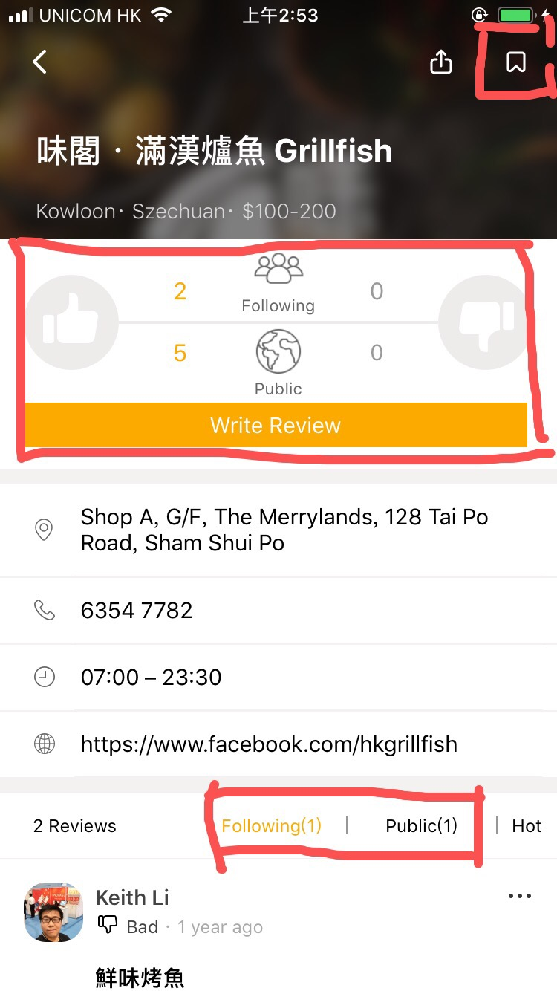

**Summary:**

**Major user journey:**

--- Using theme cards or direct search to find a restaurant --> read friends’ and public’s reviews --> choose a restaurant to visit --> rate and review

**e. Current Business Model:**

According to Foodbulous’s mission, they want to solve the problem of too many fake reviews(people being paid to promoto certain reataurants and badmouth their competitors) and advertisements on OpenRice, so they won’t take any advertisements from restaurants.

However, they are open to advertisements from other business related to the catering industry, such as credit cards, food ingredients and kithchenware, which might become their future revernue source.

1. **Problems【张一鸣】**

Explain the problems with UX elements paradigm.

4.1 The Strategy Plane

4.1.1 Site Objectives

* According to Keith, the App was designed and developed by an intern team where people with diverse backgrounds and want to present their own ideas in one product. As a result, Foodbulous seems to have many functions but none of them is outstanding enough to make the product distinguishable.
* Reason: The team members fail to reach a consensus before design the app.

4.1.2 User Needs

* Although the team identify the user pain points as mentioned before, they were not clear about what problems they want to solve and how to solve.

Conclusion: lack of deep consideration in the strategy plane.

4.2 The Scope Plane

4.2.1 Functional Specifications

* The objectives of each functions are not specific.
* Too many functions can distract the users.
* The relations between the functions are not very clear.

4.2.2 Content Requirements

* Lack of data of the restaurants.
  + The app is supposed to contain most of the restaurants in HK, however, many restaurants cannot be founded after our testing.
  + After applying all the conditions in the “discovery” functions, it turns out nothing in most cases. It can be implied that the data is not enough to support all the filters.
* Lack of data of the users. Keith mentioned a great regret that the app did not designed a place to collect the data from the users, especially the emails. So it is hard for Foodbulous backend to analyse the users and develop marketing campaign.
* At the very beginning, an app needs a long time to precipitate users, so the designers themselves need to provide more content to make the app looks “rich”. However, the official account just present a littile information, which make the app looks “lean”.

Conclusion: the logic behind the functions are not clear.

4.3 The Structure Plane

4.3.1 Interaction Design

* Some interactions are not reasonable.
  + Landing page: the default landing page is the “Moments” where show the users’ friends posts. But for the first users (who have not followed any friends), the page is totally blank without any reminders or buttons to call actions.
  + Discovery: after click the button, the users expect to see the restaurants directly. But in foodbulous, the users have to click the button on the tight-top to “apply” the conditions.
* Usually flashback (suddenly end the programe when the user acted frequently)

4.3.2 Information Architecture

* The categories of food are unclear and not attractive. It is hard for users to interprate the real meaning just for the name such as 「是但啦」/「极邪恶」,etc.

4.4 The Skeleton Plane

4.4.1 Interface Design/Navigation Design

* No “comments” function. According to Keith, one of the most important features of Foodbulous is to let users share good food with their friends. Now Foodbulous only allow people to “like” and “repost” but we think “reply” is also initial to social networking.

4.4.2 Information Design

* The secondary list of 「菜式」is missing

4.5 The Surface Plane - Visual Design

* Most of the pictures are low-quality and unattractive. The quality of food pictures is very important for a food app to maintain the users and attract new users.

Notes: Since all the interns who designed the app have left the company without leaving any materials. All the problems mentioned above are concluded from our own user experience and Keith’s limited introduction.

1. **Objective【薛徐婷】**

Goal：Revamp and redesign Foodbulous to improve its downloads and the number of users.

Objectives1: Study the current market conditions, competitors and the product’s own characteristics to find out the positioning and advantages of Foodbulous

Objectives2: Analyze the user journey and redesign the UX and UI of Foodbulous to improve the usability of the app.

Objectives3: Conduct the usability study and qualitative research to find out the result of changing.

1. **Solution**

**6.1 UX redesign**

prototype想法【夏聪聪】→体现customer journey--让food review成为桥梁，餐厅，用户

**6.2 UI Redesign**

The new UI will be grounded on our App objective and attempts to facilitate the user journey by improving the old version in the following four dimensions:

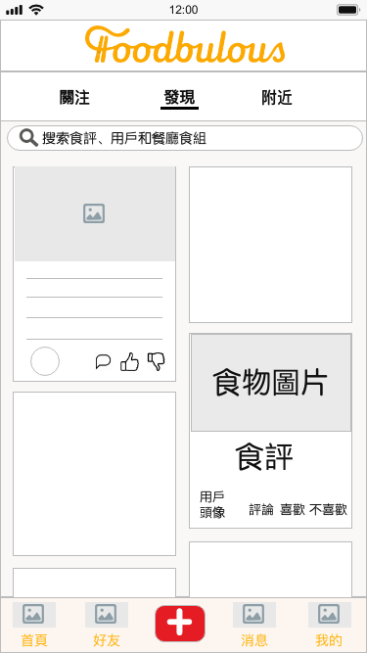

**New UI Sample (Prototype) Current UI**

① To enhance the social and community attribute of Foodbulous

--- By placing user-generated food and/or restaurant Notes (食評) on the Homepage with big and fantastic pictures;

--- By introducing “comment”, “like” and “dislike” functions to each Food Note to increase interactivity between users;

--- By enabling users to store, like, comment others’ Decks (食組) and share them to other social media platforms;

--- By introducing foodie matching system, where users who have the same favourite Food Groups will be recommended to each other.

② To improve usability of Foodbulous and increase user’s agency

--- By showing new users some recommended foodies, who have either written a number of Food Notes, or have received a number of “likes”;

--- By replacing ambiguous wordings (e.g. “空腹食早餐”, “男人的浪漫”, “偉大的媽媽”...) with more explicit and directed ones to avoid confusion;

--- By transforming “Discover (搜索餐廳)” tab to a multipurpose search bar, which is fixed at the top of every tab page;

--- By displaying “Writting Reviews (寫食評)” in a conspicuous place (i.e. navigation bar at the bottom), where users can easily find once they want to post Notes;

--- By integrating “Popular Themes (探索卡牌)” into search bar as tag suggestions (標籤聯想提示) with reference to 小紅書, and offering Autocomplete Suggestions with reference to Google

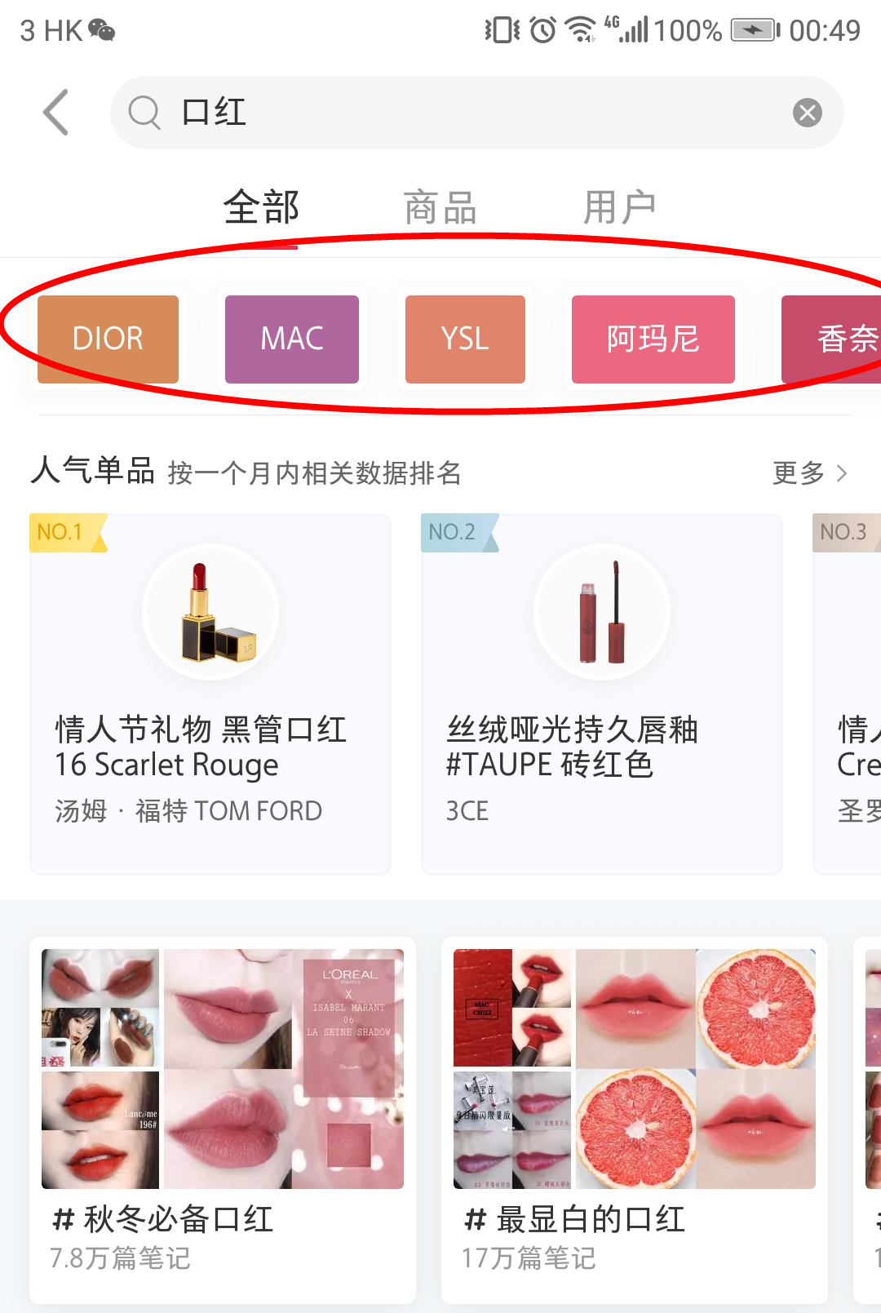

小紅書Tag suggestions

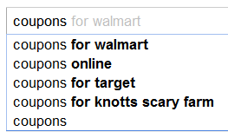

Google Autocomplete Suggestions

③ To strengthen the relationship between product (i.e App) and users

--- By adding more methods for logging in in addition to Facebook (e.g. Whatsapp, Instagram)

--- By creating sharable QR code and URL for users to invite their friends

**6.3 Customer segment【孙健翔】**

1. **Testing & Evaluation**

7.1 KPI【孙健翔】

7.2 Usability test; A/B test【孙冠琳】

Keith said that because the length of the project is limited, the redesigned products cannot be online immediately. So large-scale A/B test is difficult to carry out. In the testing phase, we will focus more on usability test.In the usability test, scenario metrics and experience scorecards will be employed.

First of all, the wireframe will be printed on paper and the redesigned app will be simulated by cropping, pasting, and coloring.

In the second step, some users will be invited to experience the app. And they will be placed in some scenarios, such as “write a review for Chan Kun Kee” or “find a delicious Italian restaurant”. In the process, their behavior will be recorded by video and will be measured and scored.

Finally, all the scores will be recorded in scorecards and the scores will be updated as the design is iterated. After the entire project is completed, the trendline can be drawn based on the score.

7.3 Qualitative research

7.3.1 Face-to-face Interview【张一鸣】

* Objectives: understand the attitudes or mind-sets of a user, by asking for the “Why” and “How”.
* Plan: deliver an interview with 5 people after every version of interactive prototype.
* Question design:

1. What do you think the app is for? --- to test the value proposition
2. Which function do you think is the most important/attractive? --- to test if the current version is successful to satisfy the user needs.
3. What is the biggest difference between Foodbulous and OpenRice? --- to test if we can achieve our goal: to solve the pain points that OpenRice cannot satisfy.
4. Which function you think can be deleted? --- to consider whether to keep some functions in the next version.
5. Other questions when observing the user flow.
6. **Timeline+展望未来（Marketing）【周天资】**
7. breakdown
8. airtable